

Renu 28 -One and Done

**As you probably know,**

**YOUR SKIN**

**is your largest organ.**

**Taking care of your skin is a matter of**

**Beauty, Health, and Comfort.**

There are thousands of ways to take care of skin --

and most skin products are highly specialized.

One for wrinkles, one for acne, another for rashes,

sunburn, moisturizing, elasticity,  bug bites,

tightening the skin around the eyes,

rough skin, blotchy skin, cuts and scrapes,

long-term sun damage ...

**What if there was ONE product that could help you have**

***overall healthier* and *more beautiful* skin?**

**Certified & Tested SAFE, Completely Non-Toxic**

**Made From Only 4 Ingredients This Unique Skin Gel utilizes Redox Signaling Molecule Technology**

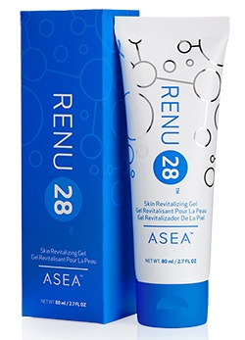

**RENU 28:  A Skin Revitalizing Gel**

**containing redox signaling molecules**

**REPAIR & COMFORT AGING OR DAMAGED SKIN**

***Please Note:***

**These Before and After photos are genuine.** Some of the people in these photos I know personally; some live in the area. Most of these photos are not taken by professionals but we did our best to "compare apples and apples" by using the same camera and lighting conditions. Each pair of pictures are the result of 28 -- or fewer -- days of applying RENU28, usually twice daily.

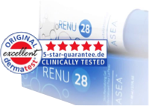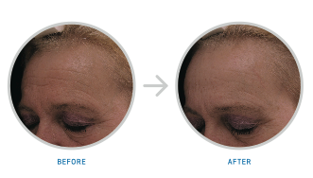

Dermatest, a highly regarded German dermatological testing institute, tests hundreds of different products using sensitive, state of the art equipment for measuring changes in the skin.  RENU 28 received its HIGHEST rating -- 5 stars.

*Photo from the actual Dermatest clinical trial of a 28 days.*

*\*Ordered test conducted by Dermatest® GmbH*

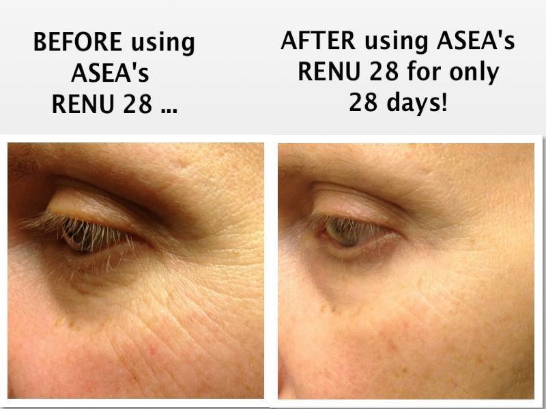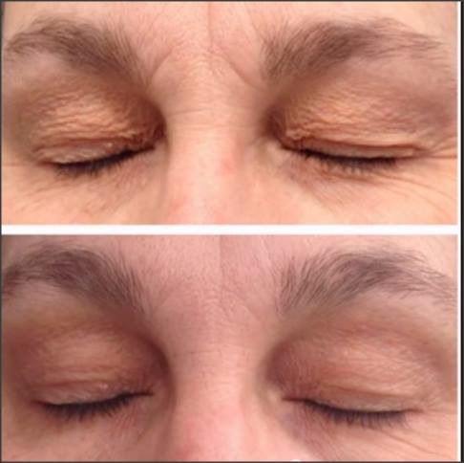

**BEFORE**

**AFTER RENU 28**



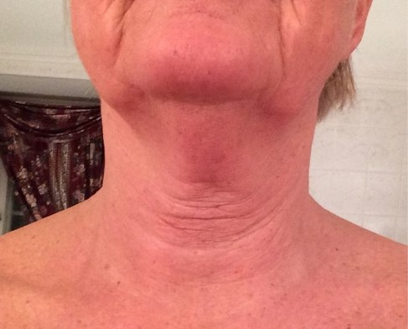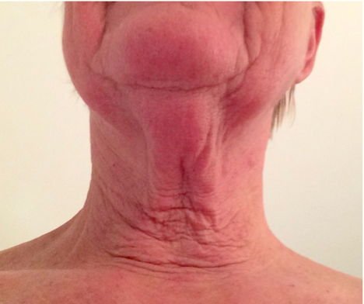

**March 19, 2014**

**April 16, 2014 28 days**

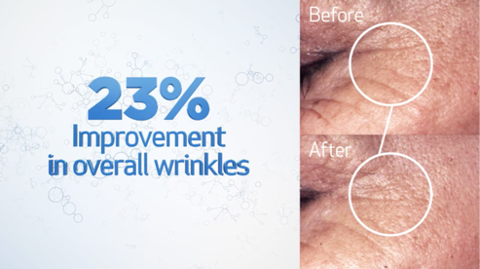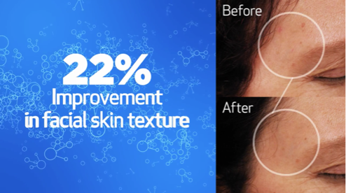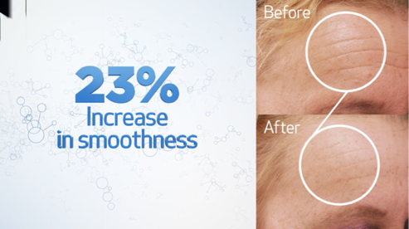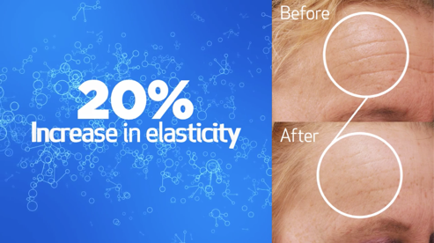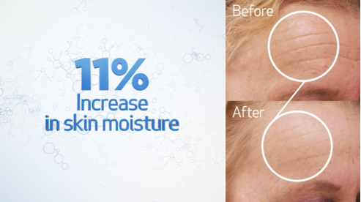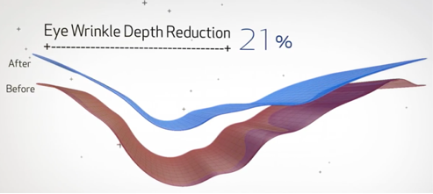



Ask How to Get Your Product for Free!

[**click here for RENU 28 video**](http://www.asea.net/en-us/whatwedo/renu28.aspx)

ASEA RENU 28 encourages the strength and resiliency of your skin cell reproduction in partnership with your body's natural efforts to keep your skin healthy. The powerful science behind RENU 28 delivers gentle, effective treatment to repair or comfort aging or damaged ski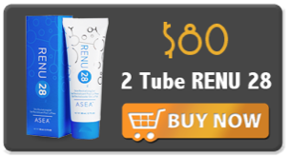n. Through Redox Signaling Technology, this unique gel provides essential support to the all-important cellular mechanisms that are the foundations of our skin's structure. RENU 28 provides critical connections and communication between cells with Redox Signaling Molecules to ensure optimum renewal and replenishment.

**CONDUCT YOUR OWN**

**28-DAY TEST!**

**• Order 2 Tubes for $80 (plus tax and shipping)**

**• Delivered to your door**

**• Allow 3-5 business days for delivery**

**• 28-day money back guarantee**

**FOR MORE INFORMATION, or to ORDER Please Contact**

**Your Name**

**ASEA Silver Executive**

**222.222.2222**

**ORDER TODAY --  for yourself or a family member**

And Yes- with such a special product comes a special business opportunity. Ask how you can be part of the growth in N. America, Europe and Australia